PROTOTYPE DEVELOPMENT OF WASTE DETECTION
BASED ON IoT IN TAMAN TERAS CIKAPUNDUNG

Yogi Sugiarto¹, Irawan Afrianto²
^{1,2} Program Studi Teknik Informatika, Universitas Komputer Indonesia
Jl. Dipatiukur No. 112 Bandung, Jawa Barat 40132
E-mail : yogisugiartto40@gmail.com¹, irawan.afrianto@email.unikom.ac.id,

ABSTRACT

Taman Teras Cikapundung where it becomes one of the tourist attractions in the city of Bandung, park manager said, He stated in maintaining cleanliness in the garden area, the volunteers faced problems, one of which was the difficulty in monitoring the condition of the park scattered by garbage, to be able to assist officers in providing access to good information, in the building of an Internet-based monitoring system of Things (IoT), where the system built has the ability to detect objects through the camera, in this study the Tensorflow library is used as object detection, Tensorflow will recognize and classify an object in a digital image, The process is done by capturing video frames to recognize the garbage that exists, then the system will send a notification that will be sent to the officer based chatbot Telegram messenger, the system uses Raspberry pi as a microprocessor, using the Tensorflow framework with a dataset of 1700 images. The results showed that with Tensorflow obtained an accuracy rate of up to 98% to detect waste in an image frame and video.
Kata kunci : Taman Teras Cikapudung, Convolutional Neural Network(CNN), Telegram Api,Internet Of Things(IoT) , Single Shot Multibox Detector(SSD)

- INTRODUCTION

1.1 Backgorund
Taman Teras Cikapundung inaugurated on January 30, 2016 by Direktur Jenderal Sumber Daya Air (SDA) Kemen PUPR Mudjiadi, Bandung Mayor Ridwan Kamil, Asda II Pemprov Jabar Deni Juanda dan mantan Menteri PU Djoko Kirmanto [1]. In doing image recognition, a method is needed to produce accurate recognition[2]. Convolutional Neural Network (CNN). Success in the introduction of large-scale images and videos[3]. Data growth has grown rapidly in this digital era[4]. With thousands of photos uploaded every day, better models and algorithms for the recognition of objects in images (Image recognition) can be developed with the help of that data.[5]. Object Detection technology is able to help facilitate the detection of objects by using the camera as a detection tool. Object detection is done using the Convolutional Neural Network (CNN) method. This method is one of the methods used in Deep Learning and can be used to recognize and classify an object in a digital image [6]. Convolutional Neural Network has a series of breakthroughs for image classification, integrating low / middle / high level features and classifier in end-to-end multilayer mode[7]. Detection of objects in the image (Object Recognition) is part of a computer visual image that serves to detect objects in an image, so that it can classify the object into an acceptable data [8]. The system can work through notifications on the telegram messenger chatbot application can display a message on the status of the terrace garden cikapundung [9].
After the inauguration of the Cikapundung Terrace Park this place became one of the tourist attractions that attracted tourists, can not be separated with what is served by tourist attractions. Cleanliness is a comfort factor in tourism, therefore, according to the manager Taman Teras Cikapundung, he said in maintaining cleanliness in the place, there are volunteers in charge of maintaining cleanliness in the park area, the volunteers faced problems, one of which was the difficulty of monitoring the trash scattered around the park area, because there are different places that are located far enough away and making rewalan have to move to monitor waste in the park area, and are less efficient, so the park is littered with garbage, it makes visitors uncomfortable, this is due to lack of supervision from the park manager, and dinas kebersihan Bandung city in waste management. Based on these problems, it is designed and implemented on a prototype, which is a technology using image processing that uses a camera [10]. This system detects garbage in the image in the area, then the system will provide notifications that will be sent to Chatbot Telegram based messenger, The system uses Raspberry Pi 3 as a controller in processing and processing images, this image is processed with the help of the Tensorflow library.

- RESEARCH CONTENTS
In this study, there are 5 stages that are carried out, starting from the problem identification stage, the data collection stage, the system analysis stage which includes object detection and system analysis that will be built, implementation, and finally conclusions.

2.1 Metode Penelitian
The methodology used uses a qualitative approach. Descriptive method aims to solve the problem by describing the state of the subject or object in research today based on the facts that are seen following the steps of the research as outlined in Figure 1.

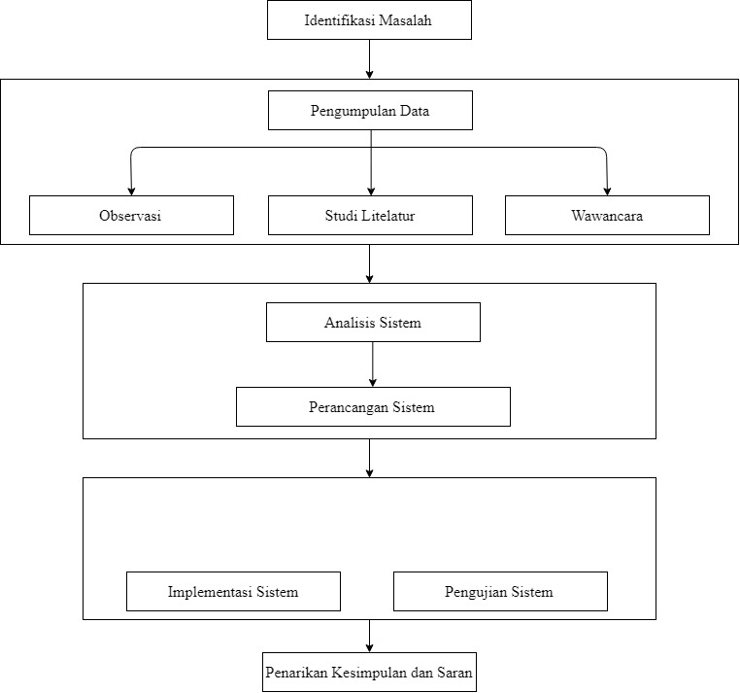
Figure 1. Research method.

In this study the data collection method was obtained directly from the research object. There are 4 stages of data collection used, namely literature studies, field studies, interviews and observations.

2.2 Taman Teras Cikapundung
Taman Teras Cikapundung inaugurated on 30 January 2016 by Direktur Jenderal Sumber Daya Air (SDA) Kemen PUPR Mudjiadi, Bandung Mayor Ridwan Kamil, Asda II Pemprov Jabar Deni Juanda and Menteri PU Djoko Kirmanto. After the inauguration of the Cikapundung Terrace Park this place became one of the tourist attractions. Cleanliness is a comfort factor in tourism, therefore, according to the manager Taman Teras Cikapundung, He said that in maintaining cleanliness in the terrace garden Cikapundung, the cleaning and maintenance team was supported by coordinating and collaborating with PD.Kebersihan Kota Bandung The following structure is the management of the terrace Cikapundung in Figure 2.
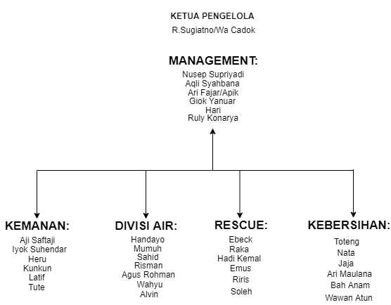
Figure 2. Management Structure Teras Cikapundung.

2.3 System Architecture.
By utilizing the Internet of Thinks technology that has the ability to transfer data over a network without requiring interaction from human to human or from human to computer, a system can be built for monitoring, to be able to recognize objects the system is built using image processing, which is processed by Raspberry pi, the following form of system architecture to be built can be seen in Figure 3.

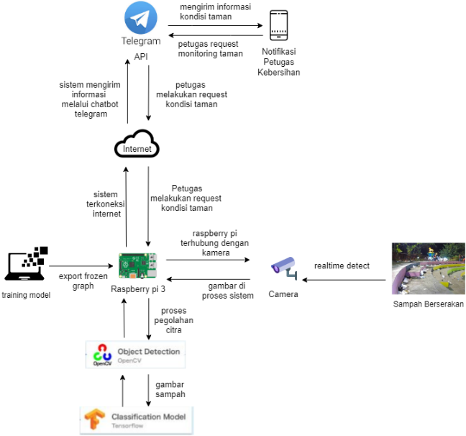
Gambar 3. System Architecture.

2.4 Analisis Jaringan Yang Di Usulkan
In general, this system requires an internet connection to connect to the devices needed and the following network analysis images can be seen in Figure 4.
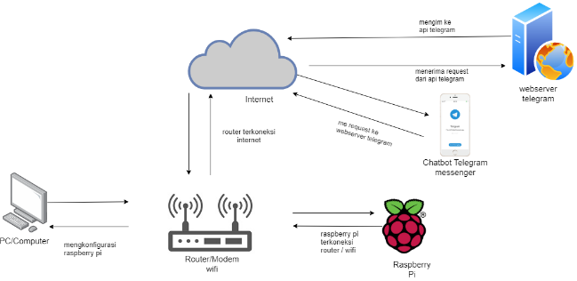
Gambar 4. Network Architecture.

2.5 Floor Plan Analysis Teras Cikapundung
Cameras installed in the Cikapundung Terrace Park area are 3 points, the first is placed in the amphitheater area, jogging track and in the parking area, because in that area often there is trash littering according to the manager of the cikapundung terrace park, following the analysis picture on the terrace garden plan Cikapundung can be seen in Figure 5 and Figure 6 that are proposed.
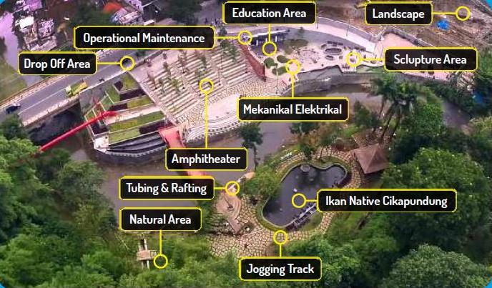
Gambar 5. park plan Teras Cikapundung.

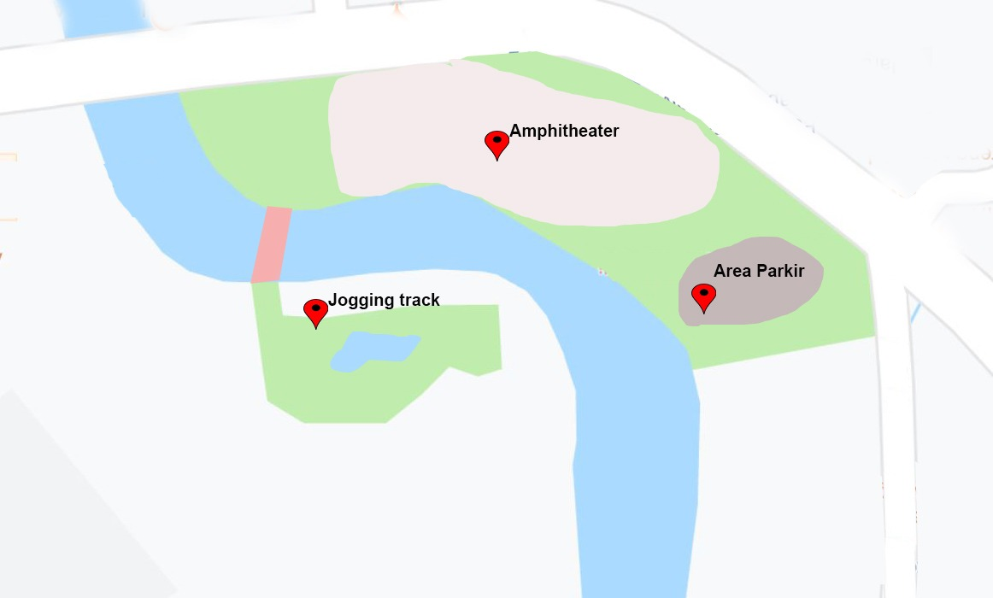
Gambar 6. Analysis of the proposed floor plan..

2.6 Object Detection Analysis
In general, the initial object detection system is as shown below, each process has its own role in carrying out the process to recognize the image, which will be explained later in the next sub-chapter.
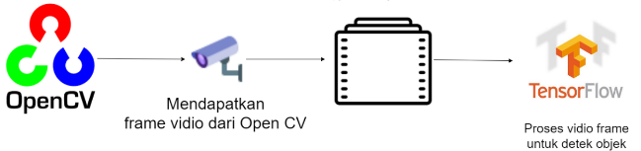
Figure 7. Analysis of the Object Detection Process.

2.7 Analysis of the Application of Tensorflow
The flow of poroses in this picture is the process of starting collecting images taken from various angles, lights, slope, and distances, from the images collected, then labeled using labels. the training process is done if the collected images are sufficient, after the trailing process is complete, and it becomes frozen graph, imported into raspberry pi the process can be clearly seen in Figure 8.

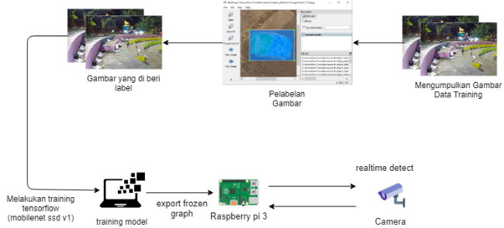
Gambar 8. Implementation Analysis Tensorflow.

2.8 Analisis Tensorflow API
Tensorflow work system is used to describe, simplify a series of processes or procedures so that they are easily understood and easily seen based on the sequence of steps of a process. The following is tensorflow workflow information in outline. Then the form in the flowchart.
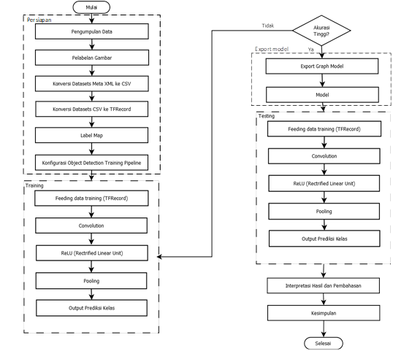
Figure 8. Tensorflow Api Analysis.

2.9 Waste Analysis
Image Analysis is an object image that is needed by this monitoring system As data for training needed by the system. This garbage object analysis can be seen in table 1.
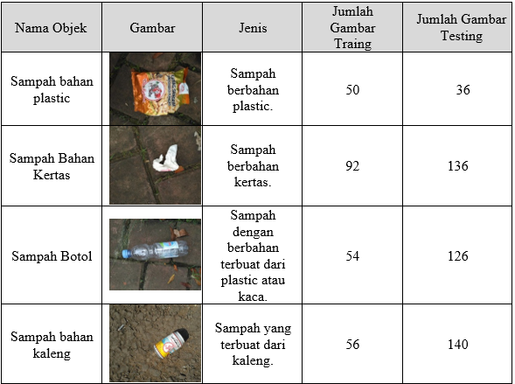
Table 1. Table Waste Type Analysis

Tensorflow recommends at least 200 images in total, making sure the images are not too large. Each must be less than 200KB, and the resolution must not be more than 720x1280. The bigger the picture, the longer it takes to train.
While for writing a table can follow the example in Table 1.

2.10 Hardware Analysis
Hardware analysis is used to describe, simplify a series of processes or procedures so that they are easy to understand and easily seen based on the sequence of steps of a process. The following is an outline of the workflow of the tool. The camera module that is placed in the Cikapundung Terrace Park gets data in the form of images that have been processed by Tensorflow, then the data is sent to the Telegram Bot Api Server. and received by the Telegram client. In order to be easily understood, the writer makes a workflow block diagram shown in Figure 6.
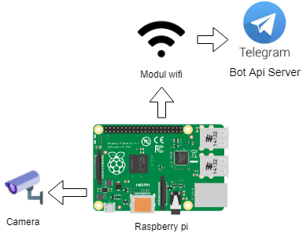
Figure 9. Hardware Analysis.

2.11 System Modeling
The system is modeled with an object approach using UML, the diagrams used include Use case in Figure 8, and Class in Figure 9.
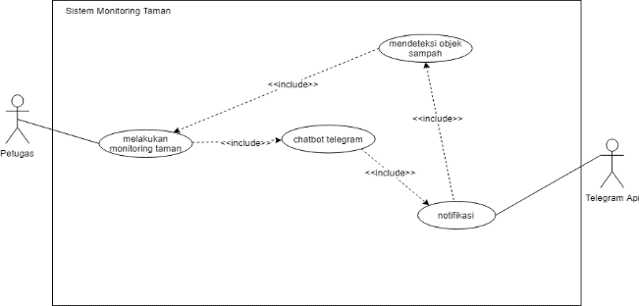
Figure 10. Use Case diagram.

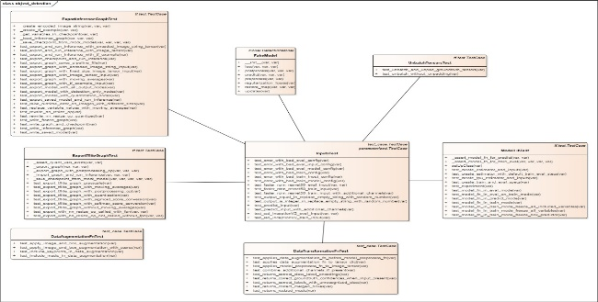
Figure 11. Class Diagram.

- Results and discussion

3.1 System Testing
System testing includes testing object detection from the camera to the raspberry pi, and Fire telegram, Testing the process of object detection.
- Testing object detection
The object detection test was carried out at three points, namely: parking area, soundscape area, jogging track area, based on tests conducted in the object detection process, the conclusion was with a camera height of 4 meters, and a distance of 5 objects were still detected with an accuracy of 40%
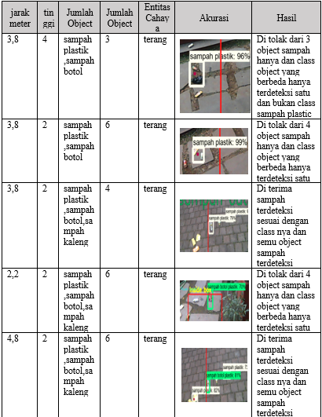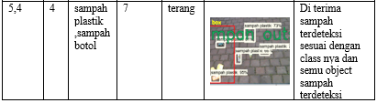
Figure 12. Object Detection Testing.

- Telegram Chatbot Testing
In testing the telegram chatbot using the internet from a wifi modem. It can be seen that the average response time needed in the process of sending responses from the server to the client is quite efficient. In addition to the average data there is data distribution which results in quite a variety of data, this is because the electronic cluster based on IoT is very dependent on the existing internet network connection so as to achieve maximum response performance with the fastest time possible faster and faster internet connection speeds are needed stable.
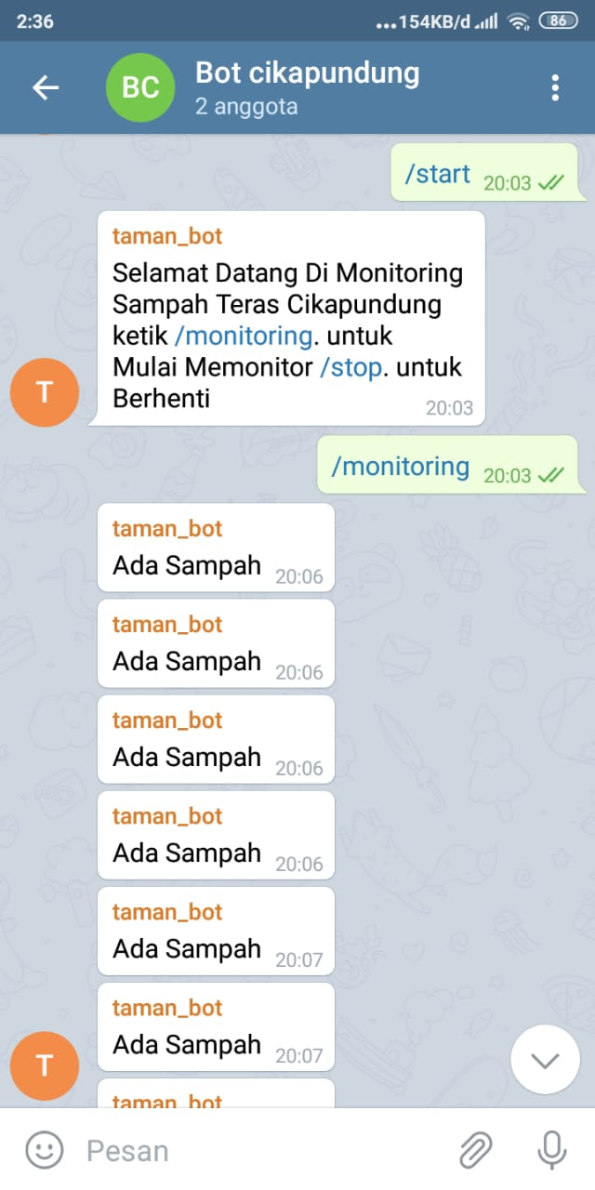
Figure 13. Chatbot Telegram Messenger.

- Conclusions and Suggestions.
4.1 Conclusion
Based on the results of research that has been done, it can be concluded that the detection of petrified IoT-based waste makes it easier for officers to monitor the park conditions, and this built system provides access to information that is easier to access using Telegram Messenger chatbot, and to detect objects using Tensorflow fire, detection objects are obtained with a fairly high degree of accuracy, in this system can produce a pretty good object detection, and produce an accuracy of 40% -99%, the level of accuracy in the test results is influenced by the number of datasets, the distance at the time of testing and images in the process the training.

4.2 Saran
This research can be developed with improved hardware. The object recognition process will be faster if the hardware is implemented with higher specifications, focused on detecting or recognizing adding training data that is more in line with the characteristics of waste at the location of the cikapundung terrace garden area. , which affects detection, so that when testing all types of image objects can be detected properly, and adding the number of step training so as to produce higher accuracy results.

THANK-YOU NOTE
In the implementation of the preparation of this thesis, the author gets a lot of help, guidance, and direction from various parties. Therefore, on this occasion the author would like to express respect and gratitude as much as possible to:
1. Mr. Ir. H. Eddy Soeryanto Soegoto as Chancellor of the University Computer Indonesia.
2. Mr. Prof. Dr. H. Denny Kurniadie, Ir., M.Sc. as Dean of the Faculty of Engineering and Computer Science, University Computer Indonesia.
3. Mrs. Nelly Indriani Widiastuti, S.Si, M.T. as Chairman of the Indonesian Computer University Informatics Engineering Program.
4. Mrs. Sufaatin, S.T., M.Kom. as a Guardian Lecturer from IF-8 class.
5. Mr. Irawan Afrianto, S, T., M.T. as a mentor who patiently guided the writer from the beginning of the preparation of this final project to be completed properly.
6. Mr Angga Setiyadi, S.Kom., M.Kom. as a reviewer at the author's seminar, which has provided better direction for the preparation of this thesis.

BIBLIOGRAPHY

- Witami, Rizki Widya, Rosita Rosita, and Sri Marhanah. "Pengaruh Pemahaman Lingkungan Terhadap Perilaku Vandalisme Pengunjung Taman Teras Cikapundung dan Taman Lansia Bandung.," Journal of Indonesian Tourism, Hospitality and Recreation, vol. 1(1)., 2018.
- Afrianto, I., & Priatama, D.” Aplikasi Mobile Pengenalan Citra Menggunakan Metode Learning Vector Quantization.” Semnasteknomedia Online, vol.1(1).20-39, 2016.
- Simonyan,Karen, and Andrew Zisserman."Very deep convolutional networks for large-scale image recognition," arXiv preprint arXiv, p. 1409.1556., 2014.
- A. Ng, Machine Learning Yearning: Technical strategy for AI engineers, in the era of deep learning, 2016.
- Pangestu, Muftah Afrizal, and Hendra Bunyamin,"Analisis Performa dan Pengembangan Sistem Deteksi Ras Anjing pada Gambar dengan Menggunakan Pre-Trained CNN Model.," Jurnal Teknik Informatika dan Sistem Informasi p-ISSN, pp. 2443, 2210., 2018.
- A. Chairul Yusri, "Implementasi Jaringan Syaraf Tiruan Dengan Deteksi Objek Kanker Kulit Melonama Menggunakan Metode Convolutional Neural Network (CNN)," (Doctoral dissertation, Universitas Pembangunan Nasional Veteran Yogyakarta)., 2019.
- K. Z. X. R. S. &. S. J. He, "Deep residual learning for image recognition. In Proceedings of the IEEE conference on computer vision and pattern recognition," pp. pp. 770-778, 2016.
- S. R. Dewi, "Deep learning Object Detection Pada Video Menggunakan Tensorflow Dan Convolutional Neural Network.," 2018.
- Effendi, Bagus Frayoga, Daniel Santoso, and F. Dalu Setiaji. "Perancangan Alat Kentongan Elektronik Menggunakan Mikrokontroler NodeMCU Berbasis Internet of Things (IoT)."
- S. J. S. E. &. N. R. Hutasoit, " Rancang Bangun Dan Implementasi Prototipe Pendeteksi Dan Pemadam Api Menggunakan Image Processing Pada Quadcopter.," eProceedings of Engineering,, p. 3(3)., 2016.

