APPLICATION CULINARH HALAL STREET FOOD IN BUSAN NAMPO-DONG BASED ON MOBILE OPERATION SYSTEMS

Muhamad Fahmi Rizal, Dr. Marliana Bw , S.Si, M.Si
Sistem Informasi, UNIKOM
fahmispino@yahoo.com

ABSTRAK

Salah satu aktifitas yang dilakukan untuk memenuhi kebutuhan akan informasi adalah browsing untuk menjelajahi internet di dunia maya. Pada saat ini pengguna smartphone dapat mengakses informasi-informasi di seluruh dunia dengan menjelajahi internet. Keterbatasan dalam komunikasi di luar negeri menyebabkan kesulitan bagi para wisatawan saat mereka berada di Negara yang memiliki bahasa yang berbeda. Namun saat ini dengan berbagai aplikasi penunjang komunikasi seperti aplikasi penerjemah, aplikasi panduan wisata dan lain-lain yang terdapat di smartphone, memudahkan para wisatawan saat berada di luar negeri. Salah satu tujuan wisata popular dari wisatawan Indonesia adalah korea selatan, hal ini dikarenakan kepopuleran dari musik pop korea (KPOP) dan drama korea. Banyak wisatawan Indonesia yang berkunjung ke korea untuk menikmati berbagai hal seperti mengunjungi tempat bersejarah, menikmati konser musik, menikmati kuliner khas korea dan lain sebagainya.
Desain penelitian yang penulis gunakan ialah penelitian deskriptif yang memiliki pernyataan yang jelas mengenai masalah yang akan diteliti. serta teknik pengumpulan data yang digunakan meliputi sumber data primer yaitu dengan cara observasi langsung ke tempat dan wawancara dengan wisatawan. Dengan metode pendekatan berbasis objek, pendekatan pengembangan sistem yang dilengkapi dengan alat-alat (usecase, activity diagram, sequence diagram class diagram dan lain-lain) dan metode pengembangan prototype yang membuat bentuk awal dari sistem yang akan di buat dan terus uji dan dikembangkan sampai sampai didapat sistem yang lengkap disebut dengan proses iteratif (iterative process) dari pengembangan sistem. Sedangkan pembuatan perangkat lunak menggunakan bahasa php, java dan database menggunakan MySQL
Maka dari itu dibuat suatu aplikasi jajanan kaki lima halal di korea yang menyelesaikan permasalahan di atas. implementasikan aplikasi ini meliputi implementasi perangkat lunak, perangkat keras, basis data serta antarmuka dari aplikasi yang dihasilkan. Tahapan akhir adalah pengujian terhadap aplikasi dengan menggunakan metode blackbox.

Kata kunci : aplikasi, jajanan, halal

ABSTRACT

One of the activities done to meet the need for information is browsing to surf the internet in cyberspace. At this time smartphone users can access information around the world by surfing the internet. Limitations in overseas communications cause difficulties for travelers while they are in countries with different languages. But this time with a variety of communications applications such as application support translator, travel guide application and others contained in smartphones, facilitate the tourists while abroad. One of the popular tourist destination of tourists Indonesia is south korea, this is because the popularity of Korean pop music (KPOP) and Korean drama. Many Indonesian tourists who visit to korea to enjoy various things such as visiting the historic place, enjoying music concerts, enjoying typical korean cuisine and so forth.
The research design that the writer uses is descriptive research that has a clear statement about the problem to be studied. As well as data collection techniques used include primary data sources that is by way of direct observation to the place and interviews with tourists. With the method of approach to object-based, approach to the development of systems that are equipped with the tools (usecase, activity diagrams, sequence diagrams class diagrams, etc.) and methods of prototype development that makes an early form of the system that will be created and continue to test and develop until Until a complete system is called an iterative process (iterative process) of system development. While making the software using the php language, java and database using MySQL
Therefore made a halal application halal food in korea that solve the above problems. Implementation of this application include the implementation of software, hardware, database and interface of the resulting application. The final step is testing the application using the blackbox method.

Keywords: application, food, halal

I. PREFACE

  - Background

Technological developments are developing rapidly and rapidly, especially information and communication technology. One important communication tool at the moment is cellular phones. Besides being practical, cellular phones also have many functions and advantages, especially in everyday life. By using a mobile phone we can interact directly with the other person without needing to meet face to face with the person we are talking to, we can exchange information easily. At first the mobile phone can be used to call and send only short messages but the growing age and the increasing need for human communication, many mobile phones have emerged that provide applications or facilities that can meet human needs in communication. In the cellphone there are applications such as MP3s, cameras, games, internet and others.
The type of cellphone that is widely used in this modern era is a smartphone. Smartphones (smartphones) are mobile phones that have capabilities and functions that resemble computers. Along with the development of the age of information and communication technology, smartphone use in this world is growing very rapidly. This is due to the high communication needs of access to information that is met with the presence of smartphones. For some people, smartphones are phones that can work using all information system software. For others, smartphones are just a telephone that provides advanced features such as e-mail, internet and the ability to read e-books.
One of the activities carried out to fulfill the need for information is browsing to surf the internet in cyberspace. At this time smartphone users can access information throughout the world by exploring the internet. Some people prefer to search for information through the internet because we can get information that is quite complete and easy to access. Many people from all over the world use smartphones in various daily activities even when they travel abroad.
Limitations in overseas communication cause difficulties for tourists when they are in a country that has a different language. But now with a variety of communication support applications such as translator applications, travel guide applications and others contained on smartphones, making it easier for tourists while abroad. One of the popular tourist destinations of Indonesian tourists is South Korea, this is due to the popularity of Korean pop music (KPOP) and Korean drama. Many Indonesian tourists visit Korea to enjoy various things such as visiting historical places, enjoying music concerts, enjoying Korean specialties and so on.
Not only are language differences a problem for Indonesian tourists, there are also other problems such as the spread of culture, religion, and others. The most obvious thing is the existence of religious differences where the majority of Koreans are not Muslim while the majority of Indonesian tourists who come to Korea are Muslims. Many Koreans consume foods made from pork which are forbidden in Islam. But not a few Korean dishes or snacks that do not contain pork can be categorized as not containing unclean foods that can be consumed by Muslim tourists.
But not a little food or snacks in Korea that do not contain food that is unclean, which is usually made from fish or from vegetables. The food did not get halal certification because there was no institution that issued halal certification in Korea. Therefore in this study the author focuses on being able to do research on street food and snacks in Korea that do not contain illicit food ingredients.
The city of Busan is one of the places frequented by tourists from overseas. Today many Indonesians visit Busan, but most of them do not yet know the culinary location of street food or foods that do not contain unclean food in Busan City. And it is also very difficult for those who are Muslim to look for food that does not contain unclean food because food in Korea contains many ingredients made from pork or other food ingredients. This is because there is no information that supports culinary tourism actors in Busan. Besides that, searching for information through websites takes a long time because it is difficult to understand Korean language and very few sites discuss halal food in Korea. Thus it is needed an application that can facilitate the search for information on food and street food snacks in Busan that do not contain unclean food ingredients but do not have halal certification along with the location of the place where the food is located. An application that can display restaurant recommendations and places that provide food and street food snacks.
Based on the description above, the authors are interested in conducting research with the title "JAJANAN FIVE FEET APPLICATION IN MOBILE BASED BUSAN CITY".

1.2 Problem Identification
Based on the description of the background of the problem described, the problem can be identified as follows:
1. There are still not many tourists who know the location or any street food in Busan because of the lack of information obtained.
2. Tourists are still having difficulty in getting information about street vendors in Busan City, both information about the location of street vendors in Korea.
3. Searching information through a website takes a long time because it is difficult to understand Korean language and very few sites discuss halal food in Korea so that an application is needed to support the needs of tourists.

1.3 Problem Solving Formulation
Based on the description above, the problems to be studied in this study can be formulated as follows:
1. How to build a street vendors guide application in Mobile-based Busan as an information medium that can meet the needs of tourists, especially Indonesian citizens.
2. How to implement the sidewalk snack guide application in Busan for tourists and Indonesians based on Mobile.
3. How to test the application of halal street vendors in Busan for mobile-based tourists.
1.4 Research Purposes
The purpose of this research is to help tourists in the city of Busan to make it easier for tourists or Muslim tourists who do not understand Korean in finding street food and snacks in Korea that do not contain unclean food in Busan's Nampo Dong area the attention of tourists in Busan City.

Research Objectives
The research objectives are as follows:
1. Build a sidewalk culinary guide application in Busan City that can be used as a guide for tourists visiting Busan City.
2. To implement a culinary tourism guide application, especially street vendors in the Mobile City of Busan.
3. To test the application guide for culinary attractions, especially street vendors in Busan City based on Mobile

1.5 Problems Limitation
In making this application, there are some limitations and problems found including:
1. This application was built by providing information on all food and street food culinary attractions in Korea that do not contain unclean food ingredients but do not have halal certification in Busan City, especially in the Nampo-dong area.
2. This application can search for street vendors or restaurants in Busan City.
3. Application users can provide ratings for street vendors or restaurants through the recommendation feature.
4. Users of the application can enter new information about a street vendor or restaurant via the five-time snack place input feature or restaurant.
5. Making a street vendors snacks application in the city of Busan uses data from Google Maps.
6. Applications that are built can only be used on smartphones and tablets that are mobile.
7. The application that is built requires an internet or wifi connection to be able to access the overall content in the application.
8. The programming language used is the Java programming language by using the Android Studio application to create programs and use SQLite for database creation.

II THEORY BACKGROUND
2.1 Defining Information Systems
Information systems can be defined as follows: A system made by humans which is consists of components within the organization to achieve a certain goal, which is to present data [2].
A set of organizing procedures which at the time of implementation will provide information for decision makers and / or to control the organization.
A system within the organization that uniting the transaction processing needs. Supporting the operations, managing in nature, and strategic activities of an organization and provide certain outside parties with their necessary reports. [2]

III EXISTING SYSTEM ANALYSIS
3.1 Company Brief History
Nampo-dong is the main commercial and shopping area in Busan, South Korea. Nampo-dong is in the Jung District ("Central District") in the southern part of the city, bordering the city river on the north side. Served by two bridges that connect Yeongdo District to the south, Nampo-dong can also be accessed by the Nampo subway station.
This area mainly consists of a long north-to-south road with a large walking area with shops, cafes, restaurants and statues or other seasonal or permanent exhibitions. The side street also has many camera shops, and heading south, the streets turn into Kangtong (Tin-Can Market) and Gukje Markets, with foreign goods and street food, and Jagalchi Market, with fresh seafood for sale. Or eat when the road approaches the port.
At the north end of Nampo-dong is the new Lotte Department Store. On the west side of the narrow elevator leads to Yongdusan Park with his tower. Nampo Station also has a wide range of underground shops.
Nampo-dong tends to attract a cosmopolitan crowd of Japanese, Russian and Western tourists. Because the area limits car access and is in a choking point between the two parts of the city and Yeongdo Island in the south, parking is a continuing problem, even though the area is easily accessible and can be reached by bus or subway.
Hotteok is a Korean pancake made from pancake dough filled with sweet stuffing, in the form of a mixture of brown sugar, honey, and ground nuts or seeds. To make it, the dough spheres that have been filled are placed on a flat pan and pressed with a special tool to be round, thin and wide. Hotteok then continues to be cooked over the pan, reversed so that it is evenly distributed, and wait until it is cooked and the outside is browned. Hotteok has a sweet taste and is sold in winter. In addition to hotteok, which is thin like a pancake, there are also those who sell hotteok which is rather thick and fluffy like fried bread.
Vision
" Being a famous Korean halal snack favored by tourists "
Mission
" Use quality ingredients and maintain the cleanliness of food made "

3.2 Research Methods
The research method is general strategy which is practised in collecting and data analysis needed; in order to respond the problem faced, and can also be called as the teaching of methods that used in the research process, and the method used is structured.
With this research the author take the basic of preparation of the research design; which is the elaboration of general science method, where the research methods is by explaining the event from the beginning of the planning until the achievement of research objectives.

3.2.1 Research Design
While the research design used by author in this research is: descriptive qualitative method.

3.3 Types and Data Collection Methods
3.3.1 Systems Approach Method
In the development of an information technology-based system required an approach and system development that will determine the process of software engineering settlement, while the system approach taken by the author is to use object-oriented approach (object oriented) and system development using prototype model.

3.3.2 Systems Development Method
System development method is a method or way used in doing system design. System development method that Author use is Prototype system development method.
Prototype is a method in system development that uses approach to develop such program quickly and gradually so that can be evaluated by user. Prototype makes the process of developing information-systems to be faster and easier, especially at the state of the user's needs is difficult to be identified.

3.3.3 Software Testing
Software testing is a process to ascertain whether all the functioning system is working properly, and to see if there are still any errors in the system. In this research, the author uses software testing using black-box testing method. Black box testing is testing the core aspects of the system regardless of the internal logic structure of the software. Black box testing is a designing data test method based on software specification. This approach is usually carried out by testers who do not participate in the software coding process.

IV RESULT AND DISCUSSION

4.1 System Design
At this stage the design of the system built is described as object oriented before coding is done in the programming language. The design of the Nampo-Dong Regional Culinary Application system is intended to produce a new system that can support the Culinary Application system to be computerized in order to streamline data as well as make the time used effective.

4.1.1 System Design Objectives
The purpose of system design is to describe a prototype that fits the user's needs. Here is the purpose of the author in designing the system:
1. This application on Android-Based Mobile Devices, is intended to be able to facilitate tourists in searching for locations and routes of halal food / snacks that are halal.
2. With this application on Android-based mobile devices, it is hoped that it can become a reference for Muslim tourists in finding street food / snacks in the Nampo-Dong area.

4.1.2 Overview of Proposed System
The application that will be created by the author is an application that displays a list of restaurants / street vendors in the Nampo-Dong area. With this application it is easy for Muslim travelers to find halal food and drinks that are delicious to eat.

V CONCLUSIONS AND SUGGESTIONS

5.1 Conclusions
From the results of the previous discussion there were several problems in the background that the author explained in Chapter I. With the development of this application, some conclusions can be drawn, namely:
1. With this application it is expected to make it easier for tourists to get information about street vendors in Busan.
2. With this application it is expected to make it easier for tourists to get information about street vendors and locations where street vendors sell.
It is expected that this system can facilitate the information search process replacing searches through sites or websites that search for information.
5.2 Suggestions
So that the proposed system can be used to run as expected, then there are some suggestions that can be taken into consideration, namely:
1. In the future it is hoped that this application can display information on street vendors in all cities in Korea.
2. In the future, this application is expected to be made for iphone cellphones with IOS.

Bibliography

[1] Yakub. Pengantar sistem informasi. Yogyakarta Graha Ilmu. 2012
[2] Leonardi Paris Hasugian, S.Kom., M.Kom., M. Eng “APLIKASI BMKG MOBILE PHONE DENGAN MENGGUNAKAN BAHASA EMROGRAMAN JAVA (J2ME)” Tahun 2010. Diakses 10 juni 2017
[3] Diana Effendi, S.T., M.T “Aplikasi Mobile Resto (M-Resto) Berbasis Android” Tahun 2013. Diakses 10 juni 2017
[4] https://kbbi.web.id/wisata diakses 23 juni 2017
[5] http://begitu.com/pengertian-wisata-kuliner-secara-lengkap-buat-kamu-yang-belum-tau/ diakses 23 juni 2017
[6] Ricangi Sinaga. Software Perangkat Lunak Komputer. Yogyakarta. Indrapura. 2008
[7] Fathansyah.2012.Basis Data. Informatika Bandung. Bandung

[8] http://www.ubaya.ac.id/2014/content/articles_detail/7/Android--Sistem-Operasi-pada Smartphone.html 23 juni 2017

DAFTAR GAMBAR

Gambar 1 Diagram Use Case diusulkan

Gambar 2 Class Diagram
Gambar 3 Deployment Diagram

- Form Login
Gambar Form Login

- Form Masuk Home
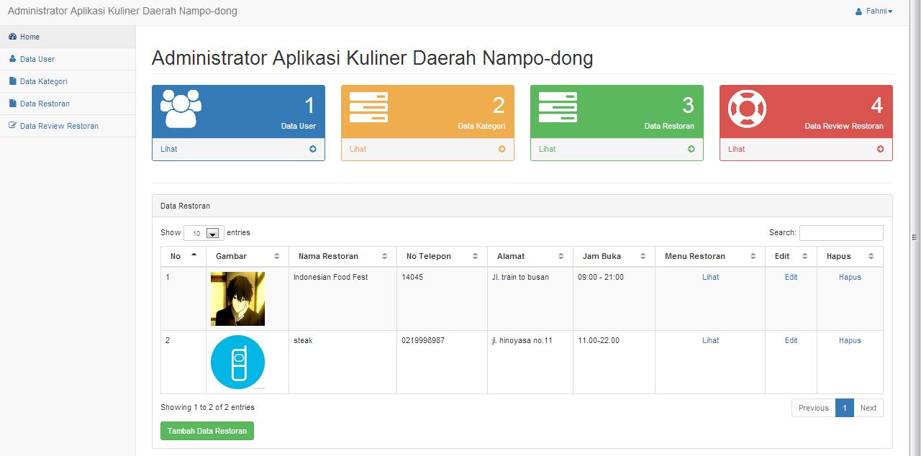
Gambar Form Masuk Home

- Form Tambah Data Restoran
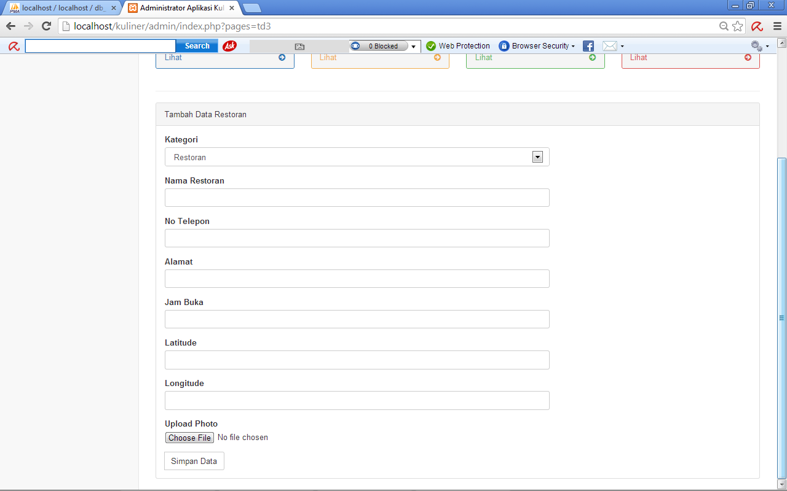
Gambar Form Tambah Data Restoran

